Problem set 2

The player is lead to a room of hexagonal shape. Each side has doors with letters A,B,C,D,E,F on each one of them as shown. The player is told to start with A. behind each door is a number. On each side there are 5 extension ports each with numbers in the power of two starting from 2^0 to 2^9. There is a monolith in the middle. The player should connect the appropriate ports to the monolith to get the sum. The solution is made into an equation(represented in binary with the connected ports as 1 and the unconnected as 0. As soon as the right answer is reached, the player is taken to the first floor of the room. The representation will be provided in the corner. The player is then given 2 containers and told to select four in the order at which the number is shown and placed in the container. The user is asked what number now is present in the container and upon identifying ten the player is said to have obtained A.

(This process repeats in each room until the player has obtained all the letters. Each room will have a unique problem and after all the letters have been obtained. The player is taken to the main room and the floor started moving upward. To a main even where the letters obtained are used to solve puzzles)

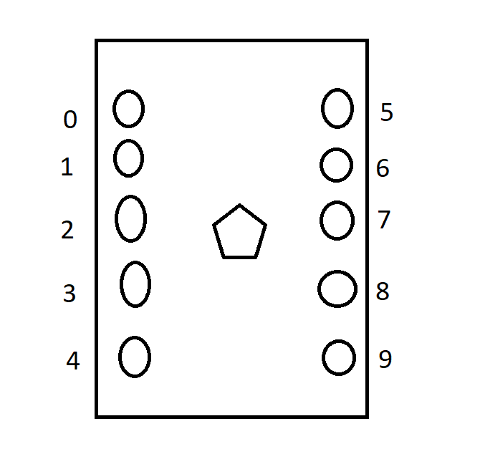

B

Once the player enters the room the number flashes on of the walls of the room. the player is told that a bunch of Lazer coming at them. The Lazers are arranged in a way which mimics the binary of the number shown. The Lazers which represent 1, are to be jumped over, the Lazers which represent 0 are harmless. Each time the player gets caught by a live Lazer, the walls close in. if the player manages to get completely crushed, they are teleported back to the hexagonal room and made to play all over again. The players are then told to collect all the numbers they jumped over and to.

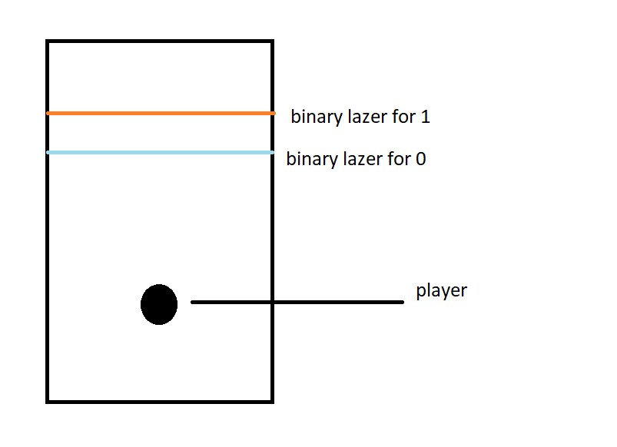

C

As a funny gag, when the player enters the room. the center contains only one box. On opening the box, the player is immediately given ‘C’. a text box appears and explains the significance of ‘C’.

D

The player then reaches the fourth room. but the room doesn’t not open. The player then must find the key that opens the door to the door so that the player can advance into the door. The player is prompted to open the open the keypad near the door. The player is presented with a set of wires. The wires are connected to the other end of the keypad. But the catch is that not all wires should be connected. There is a certain combination of wires that should be connected in a certain way. Which would unlock the door to access D

Once the door is accessed the player can enter the room. the room is dark. The player must find out what to do on their own.

**The puzzle in the dark**

The player will be provided with a flashlight. Navigating the room, the player must find 4 sets of notes. Each note is a of hex numbers, which the player must convert into decimal and finally input the four numbers into a keypad in the side of the room to turn on the lights, there on the side will be the letter D, seen on the table when the lights turn on

E

The room is completely empty.

No instruction Is given, the player once coming out of the room is the player is told to move to room F.

F

In room F the player is met with a robot. The robot after some dialogue prompts the player into battle. The battle consists of a lot of the previous puzzles all mixed. the attacks from the robot start from Lazers(room B) to random other attacks. Every alternate turns the player gets to attack. One way the player can attack is by typing out the hex of the number that flashes on the rotos monitor in front of him. There is a specific amount of time that the player is allotted to do this. The other time will be when the player is asked to stop a moving bar at the number the robot shows on his monitor. The number will be in hex.

the player can increase attack or defense by answering special questions by the robot. If the player is unable to beat the robot in the first try, the problems will be made easier and the time period longer

E(remaining)

After the player completes F, the player is told that if they haven’t gotten E, they should search all the rooms again. Each room contains another version of the robot in room F. On searching the rooms one by one, when the player gets to room D the camera zooms onto the key that the player holds. It is of the shape E. The player can find E before this by going to the items section, and examining the key after exiting room E.